**Sunlight**

Sunshine is essential for life on our planet. The existence of all plants, animals and life on land and sea depends on the sun. The movement of the atmosphere and the oceans are powered by the Sun. Without sunlight plants would not grow and crops would not ripen.

Sunlight in moderation is good for us; it helps us to maintain the balance of vitamins in our bodies and can help us to generate power through the use of solar panels. Many people do not like damp and cloudy weather and the darkness in winter can contribute to seasonal affective disorder.

Black surfaces become hotter than white surfaces in sunlight, so buildings in sunny places tend to be painted white to keep them cooler, and people wear white clothes to keep cool.

**The UV index**

Weather forecasters in the UK use the UV (ultra-violet) index to warn about the strength of the radiation from the Sun. The index depends on two factors; the position of the Sun in the sky and the amount of cloud cover.

In the UK a scale of 1 to 11 is provided for the index, combined with risk categories which tell you how harmful the Sun is going to be to humans.

**LOW** = the Sun will not prove harmful

**MEDIUM** = the Sun is not dangerous but you should not expose bare skin to the skin for over 1-2 hours

**HIGH** = the Sun is dangerous and you could burn in 30-60 minutes

**VERY HIGH** = the Sun is very dangerous and you could burn in 20-30 minutes.

You can find the current UV index for your location by viewing the full forecast from the [Met Office](https://www.metoffice.gov.uk/).

The Sun can burn our skin and hurt our eyes if we look at it directly. In addition, the Sun can cause overheating and dehydration.



**What should we wear to protect ourselves from the sun?**

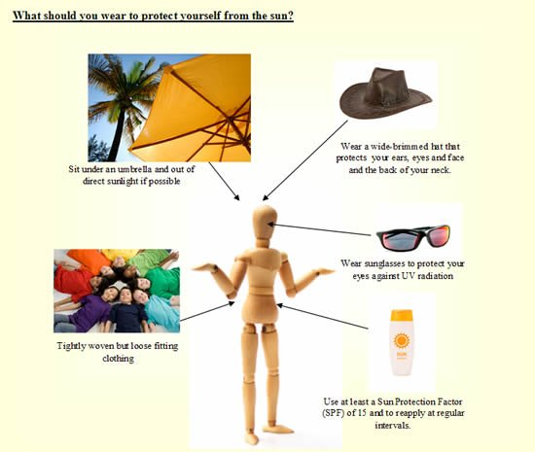

*You may also be interested in the Royal Meterological Society’s* [*four lesson scheme of work on heatwaves*](https://www.metlink.org/resource/heatwaves/)*.*