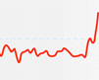
Temperatures

- How has the Earth's average surface temperature changed in the last 1000 years?

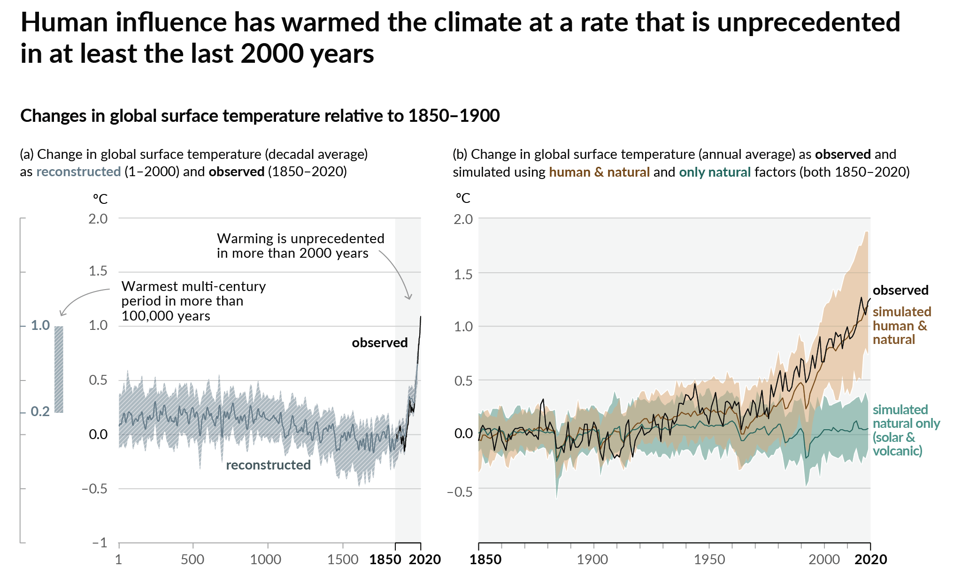
Source: IPCC Sixth Assessment Report Figure SPM.1 History of global temperature change

Human influence has warmed the climate at a rate that is unprecedented in at least the last 2000 years.

Find out more about global temperature from the Met Office Climate Dashboard webpage.

- Global average near surface temperatures
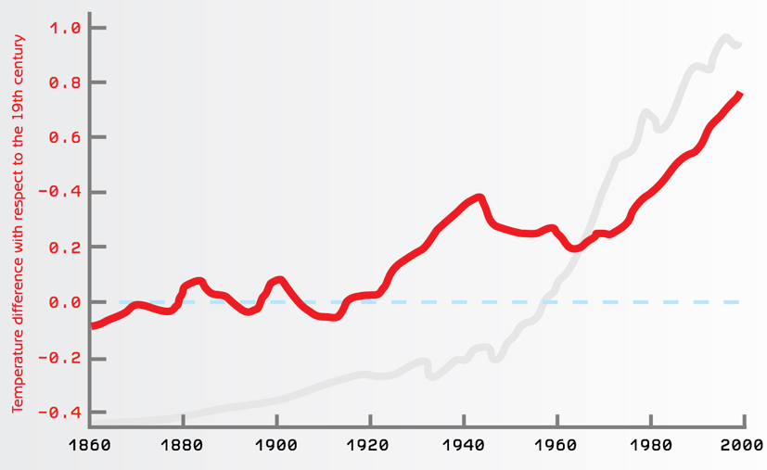

The red line on the graph shows temperature difference with respect to the 19th century.
- Total emissions of CO₂ from fossil fuel burning and cement production 1864-2014
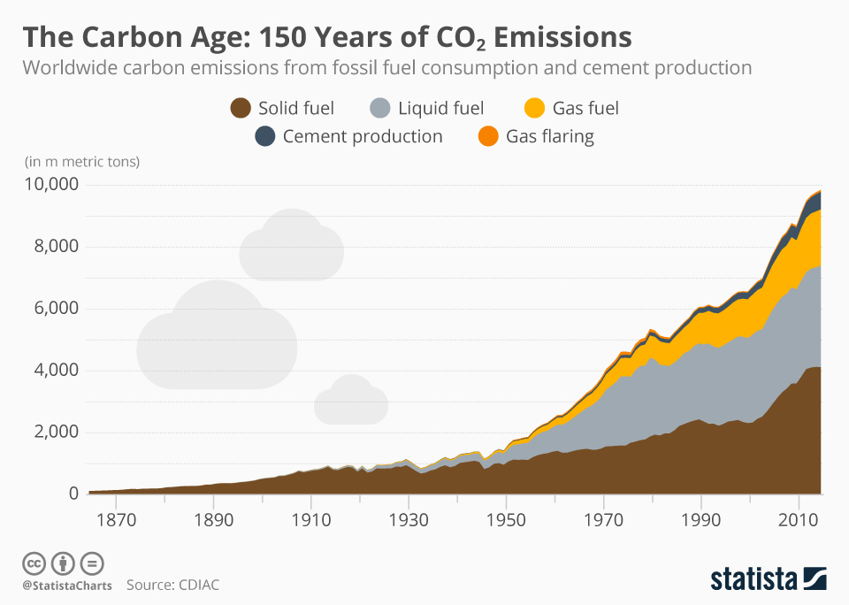
Source: The Carbon Age: 150 Years of CO2 Emissions Statista

The graph above shows the worldwide carbon emissions from fossil fuel consumption and cement production.

It is estimated that more than 400 billion metric tonnes of carbon have been released into the atmosphere from the consumption of fossil fuels and cement production since 1751, half of which was emitted since the 1980s.

